Guidelines for writing Release Notes

Introduction
The purpose of this document is to provide guidelines for writing Release Notes in order to improve content’s clarity, accuracy and consistency.

Guidelines
Below is a list of principles and guidelines with some examples. The list is not exhaustive and it may grow in time.
- Use the present tense for Release Notes. The stories in JIRA are written in the conditional tense because they describe features to be developed. Release Notes, on the other hand, describe actual features.
- Use British English instead of American English, unless you are referring to interface text, in which case you should keep the exact same spelling as that used in the application.
- Avoid referring to WHATS’ON since all Release Notes are about WOn.
Example: instead of writing “WOn will check if this product version is available”, you could write: “A check will be performed on the product version availability.”
- Structure the content:
  - for new features:
    - start with a small introduction about the new feature that you are describing, detail the feature and add a small conclusion, if need be.
    - if you refer to a previous or deprecated feature, first mention the new feature before talking about the deprecated one.
    - try to vary the wording when introducing a new feature, for example:
      - It is now possible to…
      - Users can now…
      - From now on, …
  - for fixed issues: divide the content in 2 parts, the first part being the issue description where the problem is described (with an example, if required) and the second part being the fix. If possible, add a small explanation about the fix, on top of the “This issue is fixed” sentence.
- Use connecting words like therefore, on the other hand, whereas, unlike, moreover. This really adds value to the content by providing a logical and consistent flow to the user.
- Give context, if needed, to reduce ambiguity. This can be done by adding a link to another Release Note, for example, or by giving a small explanation about a related feature.
- Use consistent formatting: it reduces ambiguity and increases a user’s ability to scan content quickly and with confidence.
  - When referring to interface text from Whats’On, use the same spelling and case, e.g. titles of group boxes are generally all capital letters.
  - Do not put colons after titles.
  - Watch the punctuation: periods at the end of sentences, commas to structure sentences and give them a good rhythm.
  - Use the following conventions:
    - Whats’On interface text for new feature: in bold as it improves scannability, see the Microsoft Manual of Style – Fourth Edition (see below), page 95: “In general, use bold formatting for user interface elements, both in procedures and in other text in instructional content.”
Quotation marks should be used when you want to use someone else’s words in your writing.
    - Whats’On interface text for deprecated feature: in italics.
    - If a word or concept has to be emphasized, underline it.
- Last but not least: use the correct terminology.
  - The best reference for this is the Microsoft Manual of Style – Fourth Edition: \\oops\dataroot\OrganisationalNG\Documentation\Style Guide\Microsoft__Manual_of_Style_Fourth_Edition.pdf.
When in doubt, a quick search will enable you to find the most suitable word.
  - Use of click, select, choose, etc. : https://wiki.mediagenix.tv/pages/viewpage.action?pageId=30703812
  - Additional information: https://wiki.mediagenix.tv/display/documentation/General+guidelines

Example of terminology:

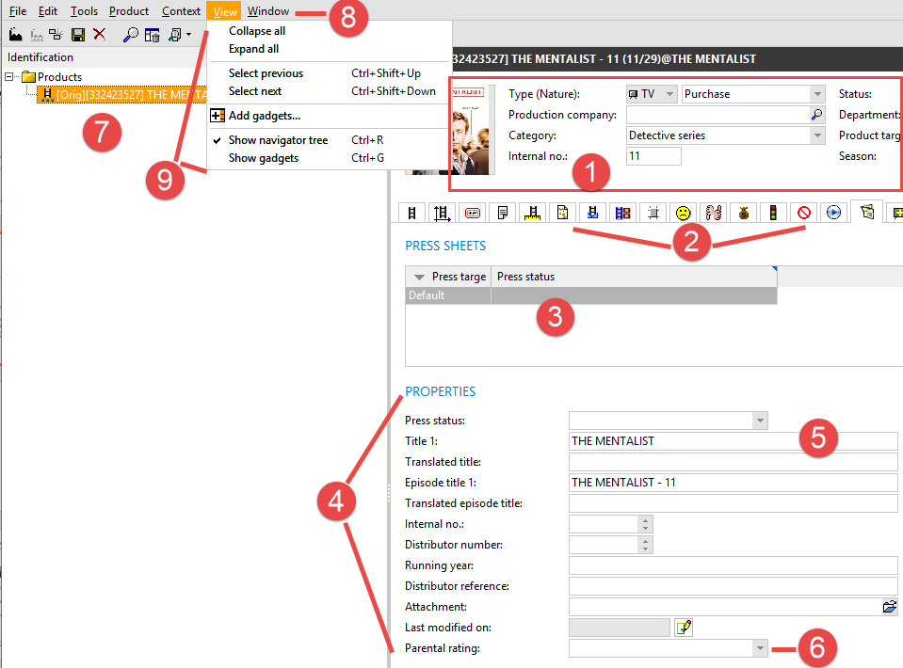

- Editor if there are tab pages, overall attributes, if there are no tab pages.
- Tab pages.
- List.
- Group box.
- Box.
- Drop-down menu. It contains a drop-down list which, in turn, contains drop-down values.
- Navigator tree.
- Menu.
- Commands.

Example of (LAVA) Release Note
https://project.mediagenix.tv/browse/RN-1680.
At the bottom, in the Issue Links part, you can find the stories (JOS tickets) for which this Release Note has been created.

